PROJECT METHODOLOGY & RESULTS
Indigenous Starchy Food Image Classifier
A machine learning model to identify visually similar indigenous starchy food types (Amala, Eba, Semo, and Pounded Yam) from photographs.

1. Model Description
The classifier is a convolutional neural network (CNN) built using transfer learning on EfficientNet-B0, a model pretrained on the ImageNet dataset (1.2 million general-purpose images across 1,000 object categories).
Rather than training a network from scratch, the pretrained EfficientNet-B0 backbone is used as a fixed feature extractor: its early layers, which already recognize general visual patterns such as edges, textures, and shapes, are frozen (not updated during training). Only a new classification head, sized to our specific food categories, is trained. This approach requires substantially less data and training time than training from scratch, while still achieving strong accuracy.
- Framework: PyTorch / torchvision
- Base architecture: EfficientNet-B0 (ImageNet-pretrained)
- Input image size: 224 x 224 pixels
- Training environment: Google Colab (GPU-accelerated, NVIDIA T4)

1.1 Intended Use Case & Scope
The model is designed to identify the primary starchy swallow food in a single photograph of one plate/dish — matching how the model will actually be used: a user photographs one meal, which typically includes the swallow alongside its normal accompaniments (soup, protein, garnish, cutlery, etc.), not an isolated close-up of the swallow alone.
This is an important scope boundary: the model classifies the whole image as belonging to one swallow category. It is not designed to detect or separately identify multiple distinct swallow-type foods within a single image, nor does it currently identify the soup or side dishes themselves. See Section 9 (Future Work) for how this could be extended in a later iteration.

2. Dataset & Image Annotation Method

2.1 Data Collection
Raw photographs of each food category were collected and gathered into an unsorted image pool prior to labeling. Two labeling passes were conducted as the dataset grew: an initial pass (Run 1) covering three categories, followed by a complete pass (Run 2) covering all four categories with a larger, more balanced image count.

2.2 Annotation (Labeling) Method
Images were manually labeled using a custom-built Python labeling tool developed for this project. The tool displays one raw image at a time; the annotator assigns the correct category using a single keyboard shortcut, which automatically sorts the file into the corresponding category folder. This method was chosen to maximize labeling speed and consistency across a large volume of images while keeping a human expert as the final authority on each label, since automated identification is not reliable for these visually similar food types.
- Tool: label_tool.py (custom Python application)
- Method: one-image-at-a-time manual review, single-keystroke category assignment
- Quality control: spot-check review pass after labeling; undo and discard functions used to correct mistakes or remove unusable images
- Output: a CSV log recording every filename-to-category decision, retained for audit purposes

2.3 Dataset Split Method
Each category's labeled images were randomly split into training (70%), validation (15%), and test (15%) subsets, using a fixed random seed for reproducibility. The test set was held out entirely from training and validation, and used only for final performance evaluation. Images were also resized/compressed prior to model upload (longest side capped, JPEG re-encoded) purely to reduce file size for transfer; this does not affect training, since the model resizes all images to 224x224 pixels regardless.

2.4 Dataset Composition — Run 1
Initial proof-of-concept pass. Pounded Yam had no labeled images yet at this stage and was excluded.
Category | Total | Train | Validation | Test
Amala | 307 | 214 | 46 | 47
Eba | 160 | 112 | 24 | 24
Semo | 178 | 124 | 26 | 28
Pounded Yam | 0 (not yet labeled) | - | - | -
Total | 645 | 450 | 96 | 99

2.5 Dataset Composition — Run 2
Complete dataset covering all four categories, with a substantially larger and better-balanced image count per category than Run 1 (all four categories within a 302-333 image range, compared to a roughly 2x spread between the largest and smallest category in Run 1).
Category | Total | Train | Validation | Test
Amala | 309 | 216 | 46 | 47
Eba | 331 | 231 | 49 | 51
Pounded Yam | 302 | 211 | 45 | 46
Semo | 333 | 233 | 49 | 51
Total | 1,275 | 891 | 189 | 195

3. Training Process
The same training configuration was used for both Run 1 and Run 2, so results are directly comparable.

3.1 Data Preprocessing & Augmentation
Training images were augmented to improve the model's ability to generalize to new, unseen photographs (different lighting, angles, and framing):
- Random horizontal flip
- Random rotation (up to 20 degrees)
- Color jitter (brightness, contrast, and saturation varied +/- 20%)
- Resizing to 224 x 224 pixels and normalization using ImageNet mean/standard deviation
Validation and test images were only resized and normalized (no augmentation), so evaluation reflects performance on realistic, unaltered images.

3.2 Model Configuration
- Loss function: Cross-Entropy Loss
- Optimizer: Adam, learning rate 0.001
- Batch size: 32
- Epochs: 15
- Only the classifier head's parameters were updated; the pretrained backbone remained frozen

3.3 Training Monitoring
Training and validation loss/accuracy were recorded after every epoch and plotted to check for overfitting (a divergence between training and validation performance). See the training curve figures in Sections 4.1 and 5.1.

4. Model Performance Results — Run 1
Evaluated on the held-out test set (99 images, never seen during training or validation).

4.1 Training Curves
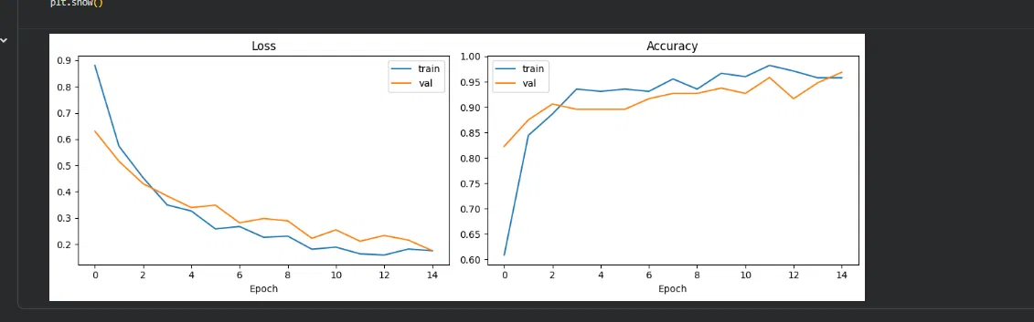
Figure 1. Run 1 training and validation loss (left) and accuracy (right) across 15 epochs. Validation tracks closely with training throughout, indicating good generalization without overfitting.

4.2 Overall Accuracy
96% (95 of 99 test images correctly classified)

4.3 Per-Category Precision, Recall, and F1-score
Category | Precision | Recall | F1-score | Support
Amala | 0.96 | 0.98 | 0.97 | 47
Eba | 0.92 | 0.92 | 0.92 | 24
Semo | 1.00 | 0.96 | 0.98 | 28
Accuracy (overall) |  |  | 0.96 | 99
Macro avg | 0.96 | 0.95 | 0.96 | 99
Weighted avg | 0.96 | 0.96 | 0.96 | 99

4.4 Confusion Matrix
Actual \ Predicted | Amala | Eba | Semo
Amala | 46 | 1 | 0
Eba | 2 | 22 | 0
Semo | 0 | 1 | 27

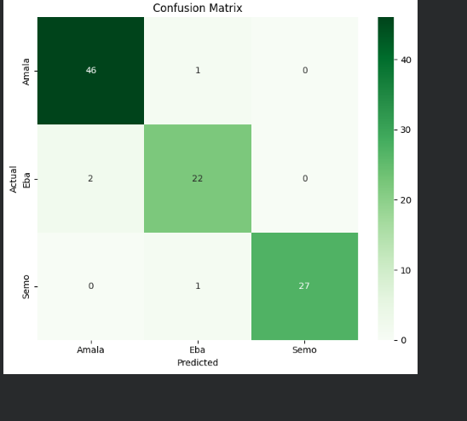
Figure 2. Run 1 confusion matrix (3 categories, test set).
Rows represent the true category; columns represent the model's prediction. The small number of errors were concentrated between Amala and Eba (1 image of Amala misclassified as Eba; 2 images of Eba misclassified as Amala). No errors involved Semo.

5. Model Performance Results — Run 2 (Full Dataset, 4 Categories)
Evaluated on the held-out test set (195 images, never seen during training or validation).

5.1 Training Curves
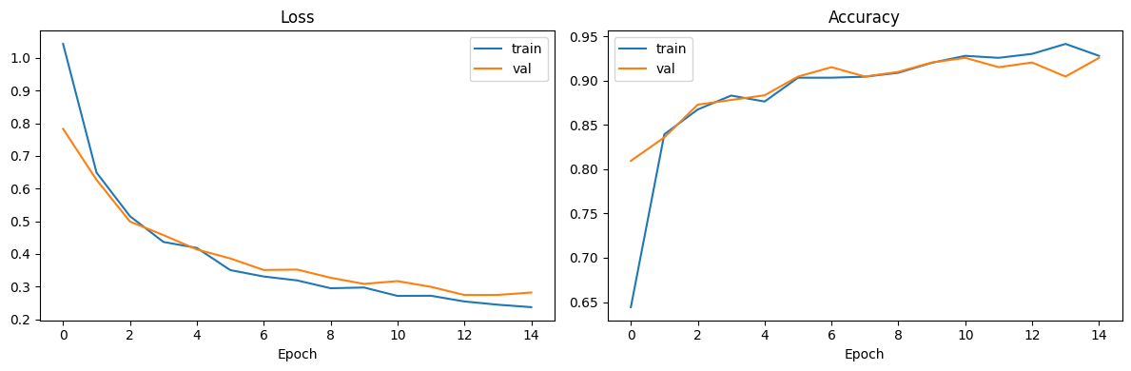
Figure 3. Run 2 training and validation loss (left) and accuracy (right) across 15 epochs, 4 categories. Validation accuracy climbs from 81% to a final 92.6%, tracking closely with training throughout.

5.2 Overall Accuracy
93% (181 of 195 test images correctly classified)

5.3 Per-Category Precision, Recall, and F1-score
Category | Precision | Recall | F1-score | Support
Amala | 0.90 | 0.98 | 0.94 | 47
Eba | 0.92 | 0.88 | 0.90 | 51
Pounded Yam | 0.93 | 0.91 | 0.92 | 46
Semo | 0.96 | 0.94 | 0.95 | 51
Accuracy (overall) |  |  | 0.93 | 195
Macro avg | 0.93 | 0.93 | 0.93 | 195
Weighted avg | 0.93 | 0.93 | 0.93 | 195
Precision: of images predicted as this category, the percentage that were correct. Recall: of all actual images of this category, the percentage correctly identified. F1-score: the balance between precision and recall.

5.4 Confusion Matrix
Actual \ Predicted | Amala | Eba | Pounded Yam | Semo
Amala | 46 | 0 | 1 | 0
Eba | 5 | 45 | 0 | 1
Pounded Yam | 0 | 3 | 42 | 1
Semo | 0 | 1 | 2 | 48
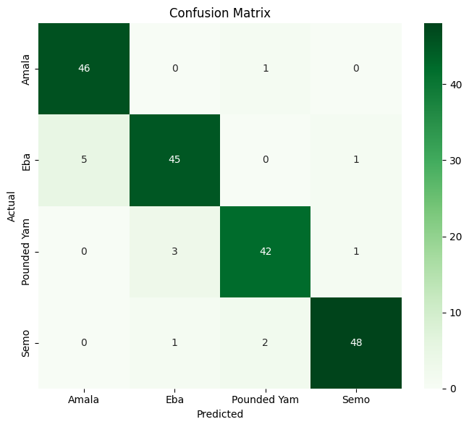
Figure 4. Run 2 confusion matrix (4 categories, test set).
The largest single source of error is 5 Eba images misclassified as Amala, consistent with the Amala/Eba confusion already observed in Run 1 — reinforcing that these two categories are the most visually similar pair in this dataset. Pounded Yam shows a secondary confusion with Eba (3 images), while Semo had the fewest errors overall (3 total, spread across Eba and Pounded Yam).

5.5 Sample Prediction Images
A sample of test images below shows the model's predicted category and confidence score for one correctly-classified and one misclassified example per category (green titles indicate a correct prediction, red indicates a misclassification).
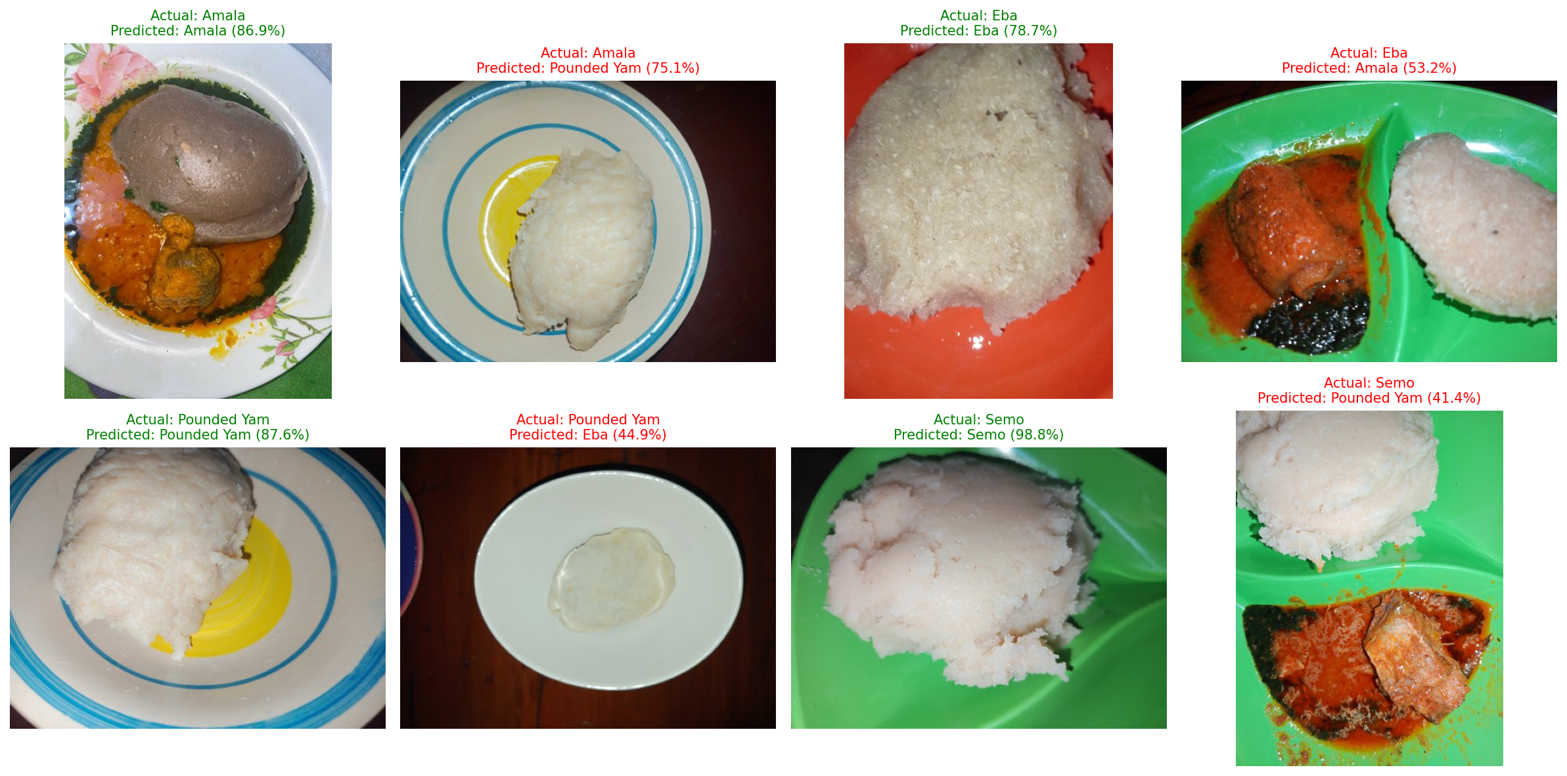
Figure 5. Sample Run 2 test predictions with model confidence. Note the misclassified Eba example predicted as Amala at only 53.2% confidence, and the misclassified Semo example predicted as Pounded Yam at 41.4% confidence — both low-confidence errors, suggesting the model itself was 'uncertain' on these rather than confidently wrong.

6. Cross-Run Comparison
Overall accuracy decreased slightly from 96% (Run 1, 3 categories) to 93% (Run 2, 4 categories). This is expected and not a sign of a worse model: Run 2 is solving a strictly harder problem (one additional, visually similar category) on a larger and more balanced dataset. The Amala/Eba confusion pattern was consistent across both runs, which strengthens confidence that this reflects a genuine visual similarity between those two foods rather than a data artifact from either individual run.
The improved category balance in Run 2 (302-333 images per category, versus a roughly 2x spread in Run 1) also means Run 2's accuracy figure is more trustworthy as a realistic estimate of real-world performance, since Run 1's higher score was partly measured on an imbalanced dataset that could favor the majority category.

7. Note on mAP (mean Average Precision)
mAP is a standard metric for object detection tasks, where a model must both locate (via bounding boxes) and classify objects within an image. This project is an image classification task (assigning one category label to an entire photo), for which accuracy, precision, recall, F1-score, and the confusion matrix reported above are the applicable and standard metrics. mAP is not reported because it does not apply to this task type as currently scoped, and computing it would require re-annotating the dataset with bounding boxes rather than whole-image category labels.
mAP would become directly relevant in a future iteration that identifies the soup or side dishes accompanying the swallow within the same photo (see Section 9), since that would require the model to both locate and classify multiple distinct food items within one image — the exact scenario mAP is designed to measure.

8. Limitations
- Run 1 excluded Pounded Yam entirely, as no labeled images existed for it at that stage; this is resolved in Run 2.
- Both runs reflect a single training run rather than an average across multiple runs, so reported metrics carry some run-to-run variance.
- Generalization / shortcut-learning risk: since real-world photos include the swallow's normal plate context (soup, protein, sides), there is a possibility the model partly learns to associate a specific side dish or plate style with a category, rather than purely the swallow's own visual properties. Both training and real-world usage involve full-plate photos, so this is a lower risk than it would be for a model trained on isolated close-ups, but it has not been formally tested (e.g. by evaluating on photos with deliberately varied, non-typical side dishes per category).
- Dataset diversity of accompanying sides/soups per category has not been formally audited; a category whose training photos happen to share very similar sides could be more exposed to the above risk than one with a broad mix.
- The model classifies a single dominant swallow per image; it does not detect or separate multiple swallow-type foods if more than one appears in the same photo.

9. Future Work

9.1 Extending to Soup / Side Dish Identification
A natural extension of this project is identifying not just the swallow but also the accompanying soup or side dish within the same photo. Unlike the current whole-image classification approach, this would require:
- Re-annotating a dataset with bounding boxes drawn around each distinct food item in an image (rather than one label per whole photo), using an annotation tool such as LabelImg, CVAT, or Roboflow.
- Training an object detection model (e.g. YOLO or Faster R-CNN) rather than a pure classifier.
- Reporting mAP as the primary performance metric, alongside per-class precision/recall, since this task requires evaluating both correct classification and correct localization of each food item.
This is a substantively larger undertaking than the current classification model and would be scoped as a distinct project phase.

9.2 Other Potential Improvements
- Expand and audit dataset diversity (different plates, lighting, and side-dish combinations per category) to reduce the shortcut-learning risk noted in Section 8.
- Fine-tune deeper layers of the backbone (currently frozen) once more data is available, which may further improve accuracy on the harder Amala/Eba distinction.
- Evaluate the model across multiple training runs to report accuracy with a confidence range rather than a single-run figure.

10. Run Log
Run | Categories | Total Images | Status
Run 1 | Amala, Eba, Semo | 645 | Complete — see Section 4
Run 2 | Amala, Eba, Semo, Pounded Yam | 1,275 | Complete — see Section 5

